**M.C. Escher’s full name is Maurits Cornelis Escher. He was born on June 17, 1898 and passed away on March 27, 1972. He was born in Leewarden, The Netherlands. His father was a civil engineer by the name of George Arnold Escher, and his mother’s name was Sara Gleichman. When he was 5 years old he moved to “Arnhem.” There he took carpentry and piano lessons until he was 13. He had bad grades, but was really good at drawing. After graduating in 1918, he attended the Haarlem School of Architecture and Decorative Arts. He left the school in 1922, and travelled through Italy and Spain where he received inspiration. In Italy he met Jetta Umiker, whom he married in 1924. They settled in Rome and stayed there until 1935. His son Giorgio Arnaldo Escher was born while he was in Rome. The moved right before world war II to Switzerland, where he lived for 2 years. Escher was unhappy there and moved to Ukkel, near Brussels, Belgium. The war then forced them to move again in January 1941 to Baarn, the Netherlands. Where Escher lived until 1970. Many of his popular works come from this period of his life. Escher moved to Rosa-Spier in 1970, a home for artists, which allowed him to have a studio of his own. He died there at 73 years of age.**

**Having attended Haarlem School of Architecture and Decorative Arts, many of his works are known for being mathematically inspired. Escher liked to explore infinity, architecture, and tessellations in his drawings. He also experimented with drawing structures that are impossible to construct in real life. Living in Italy and the Netherlands, and seeing lush landscapes also inspired many of his works. All of his art originated as images in his mind, instead of things he saw. From his education at Haarlem School he primarily worked on woodcuts, lithographs, and sometimes mezzotints. Escher’s artwork appeals to mathematicians and scientists, who recognize the use of geometric distortions in his work. M.C. Escher never really received any mathematical training, all his understanding of mathematics is visual and intuitive. Escher would use geometric grids as the basis for some of his sketches, when he then overlaid with more of his designs, mainly animals like birds. In 1941 he wrote a paper, named Regular Division of the Plane with Asymmetric Congruent Polygons. He further studied mathematics such as topology and incorporated it into his drawings. He created hyperbolic tessellations, and tried representing infinity on a two-dimensial planes. He wrote another paper called Regular Division of the Plane.**

***I chose to do M.C. Escher because a lot of his work is thought provoking. Like, the never-ending staircase is very interesting to look at. As is the hands drawing each other. I find it amazing that he has an intuitive understanding of mathematics. It’s also cool how all of his artwork originates as images in his mind, instead of drawing from observation. The time period of when he created his artwork is also unusual. He created most of it in his later life in a post-world war II climate. He also has a museum dedicated after him, in the Hauge, The Netherlands (it opened in 2002). It’s also an interesting fact that he has an asteroid named after him, 4444 Escher.***

[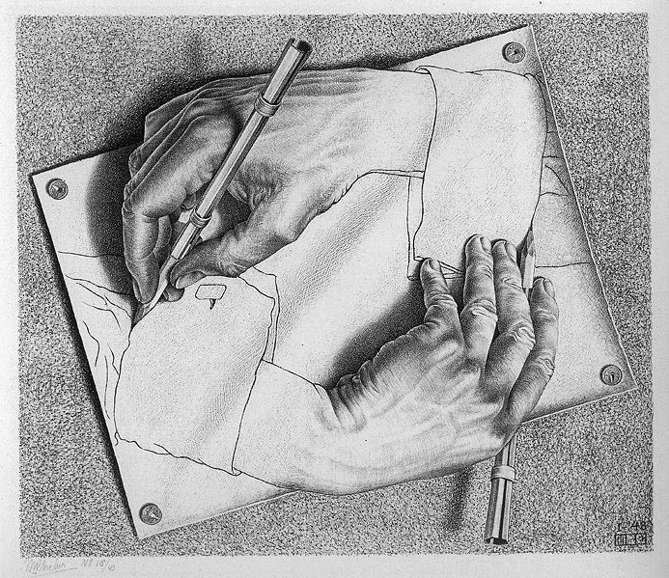](http://upload.wikimedia.org/wikipedia/en/b/ba/DrawingHands.jpg)

[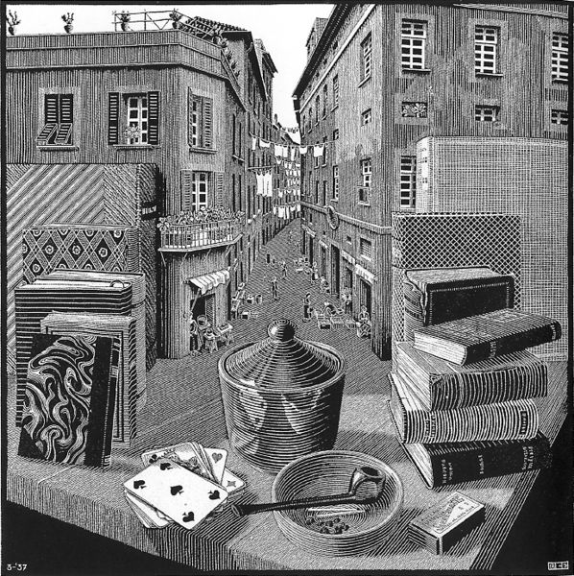](http://upload.wikimedia.org/wikipedia/en/b/bb/Escher%2C_Still_Life_and_Street.jpg)

[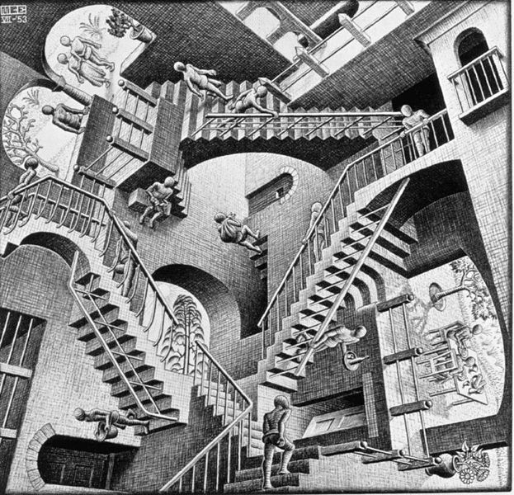](http://upload.wikimedia.org/wikipedia/en/a/a3/Escher%27s_Relativity.jpg)

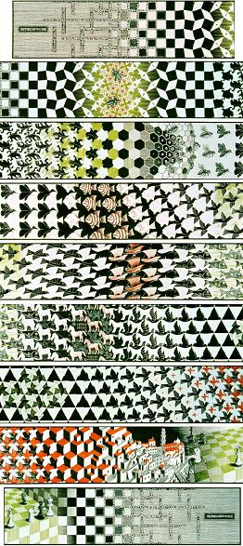

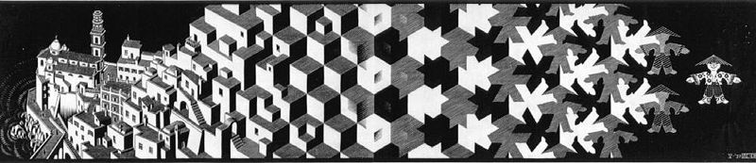

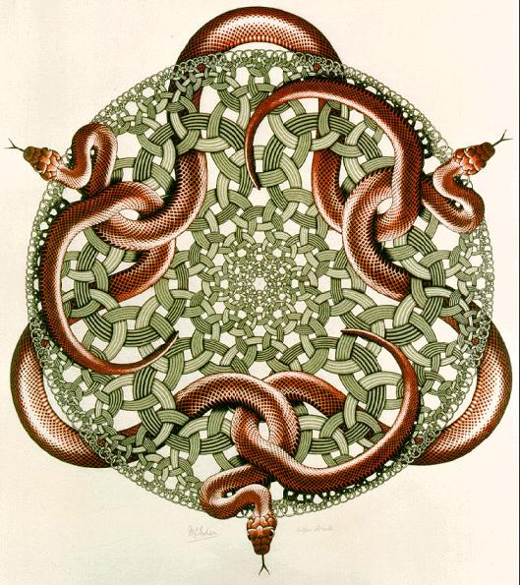

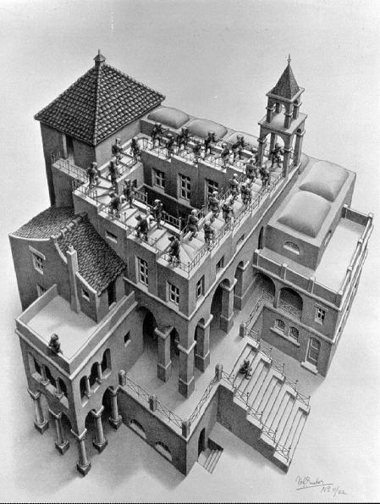

***Ascending and Descending: 1960: a lithograph print depicting people***

***ascending and descending stairs that are impossible to build***

***Snakes: 1969: Escher’s last print***

***Still Life and Street: 1937: M.C.’s first print of an impossible reality***

***Drawing Hands: 1948: Two hands are drawing each other. . .***

***Relativity: 1953: A famous piece showing a paradoxical world where***

***the normal laws of gravity do not apply.***

***Metamorphosis I: 1937: one image is morphed into another pattern…***

***Metamorphosis III: 1968: original measured 7.5 x 268 inches***

**By: Jim Brendlinger**